**Semester Project ICT LAB**

Date of Submission: 3rd December 2023

Submitted to: Prof. Kainat Nazir

Class: BSCSev 1-B

Group Members:

1. Aeman Aasim (232384)
2. Bisma Maheen (232429)

**Project Name:**

***BLOGGING WEBSITE***

***“AirTime.pk”***

**Blogging Website:**

A blogging website is an online publication platform where people may write and share blog entries. These articles can be on whatever the blogger deems interesting, including news, opinions, tutorials, personal experiences, and anything else. A few of the well-known blogging platforms are *Tumbler, Medium, Word Press*, and Blogger. These websites frequently offer themes and features to make it simple for users to start and maintain blogs.

***AirTime will allow AU students to write and share different blog entries.***

**Purpose for Creating this Website:**

Blogging offers a forum for the exchange of knowledge, skills, and information on certain subjects. It enables people to share their ideas, perceptions, and experiences with a worldwide audience. Blogging are a creative outlet for certain people. It enables individuals to share their written expressions of ideas, concepts, and creativity with a larger audience.

*AirTime will help AU Students as a community to grow, learn, and choose their path in learning different yet informative things*.

**Target Audience:**

*Air University Students weather undergraduate, graduates and doctors as along as they are a part of Air University.*

**Objectives:**

Following are the objectives of AirTime.pk:

* To provides a platform to share information, insights, and expertise on specific subjects, reaching all AU Students.
* To build a community of like-minded individuals, creating a space for discussion, collaboration, and learning from one another.
* By providing valuable content, help students in their educational pursuits, career advancement, or personal development.
* Students will stay up to date with all the upcoming advancement in technology and learning from graduated students’ experience.
* It can serve as a portfolio or showcase for students, demonstrating their expertise and teaching style.

**Features:**

* Students will login on the website with their University Username and will be able to “lets Blog”.
* Students will be able to choose their area of interest by giving them all the available courses options to explore.
* Students will have the privilege to write and share their experience in a form of blog.
* Students will also be given the benefit to become an admin who will approve the post shared and will take care of websites security and ethical behavior.

**Conclusion:**

AirTime will help all the students of Air University irrespective of their location to learn, help and share their experience. It will help them grow as a community as well as individuals.

**Project Display:**

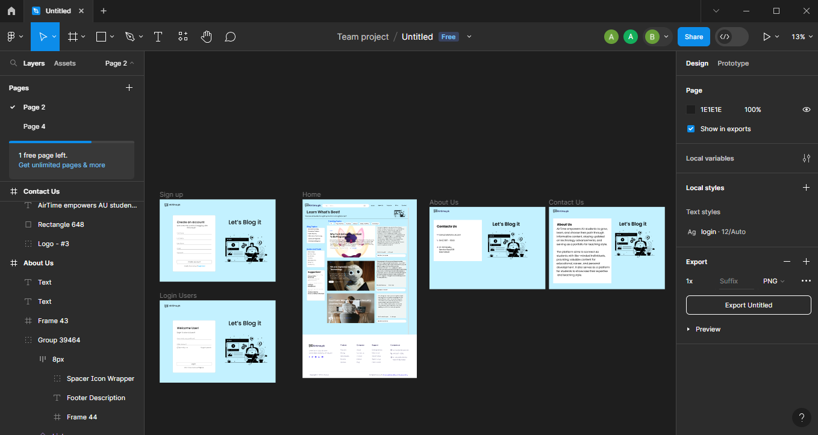

**Step 1:**

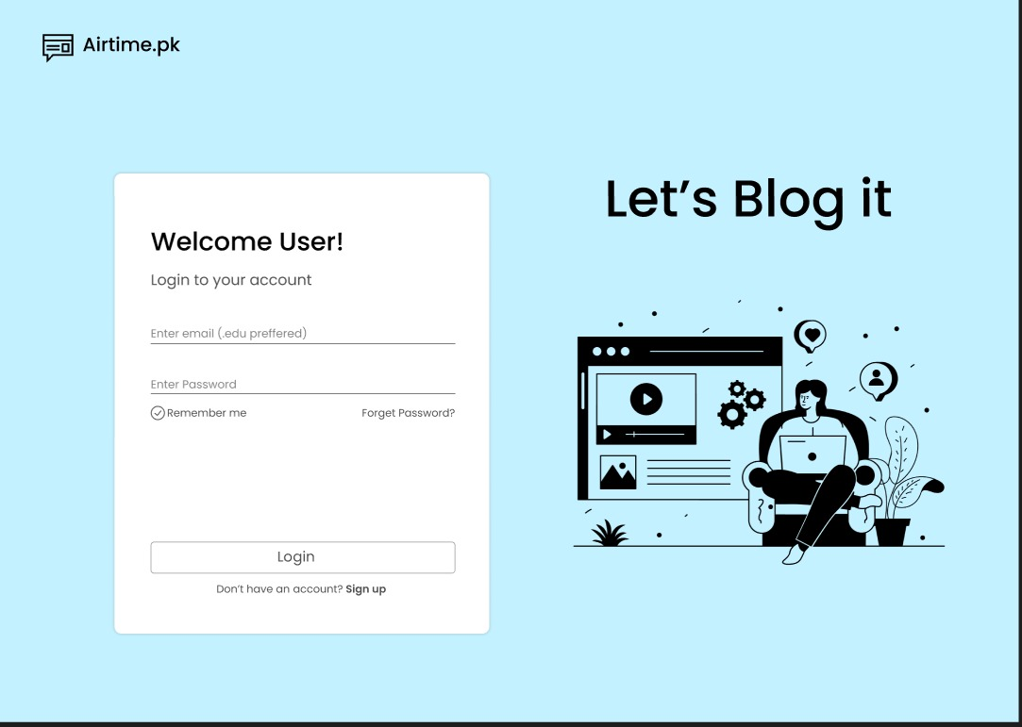

**Step 2:**

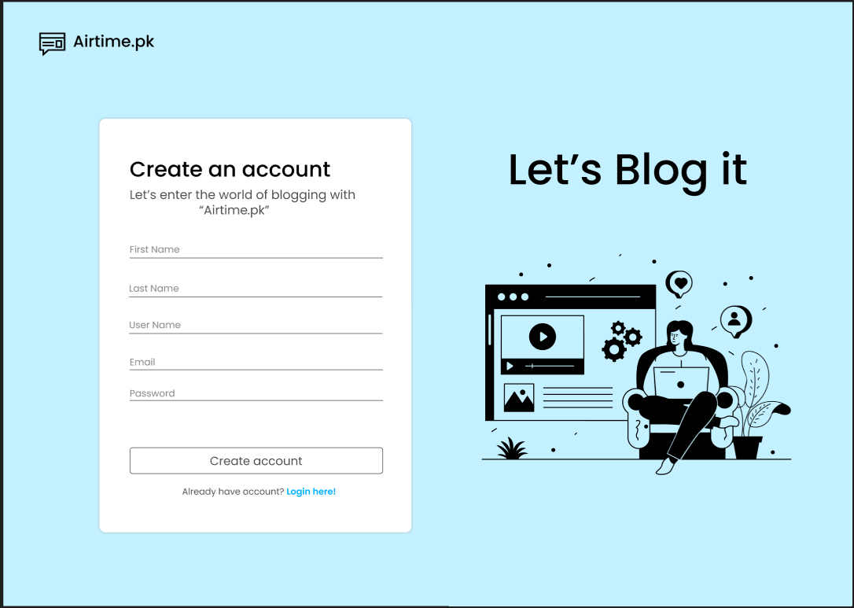

**Step 3:**

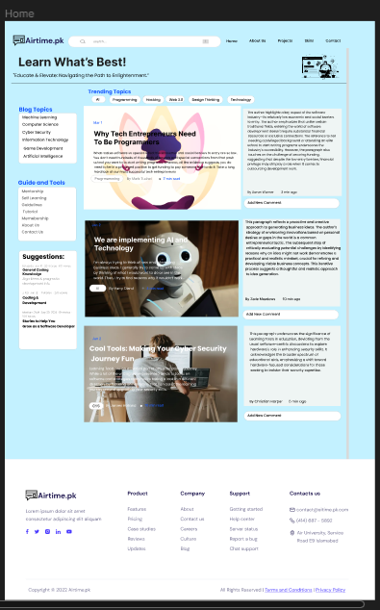

**Step 4:**

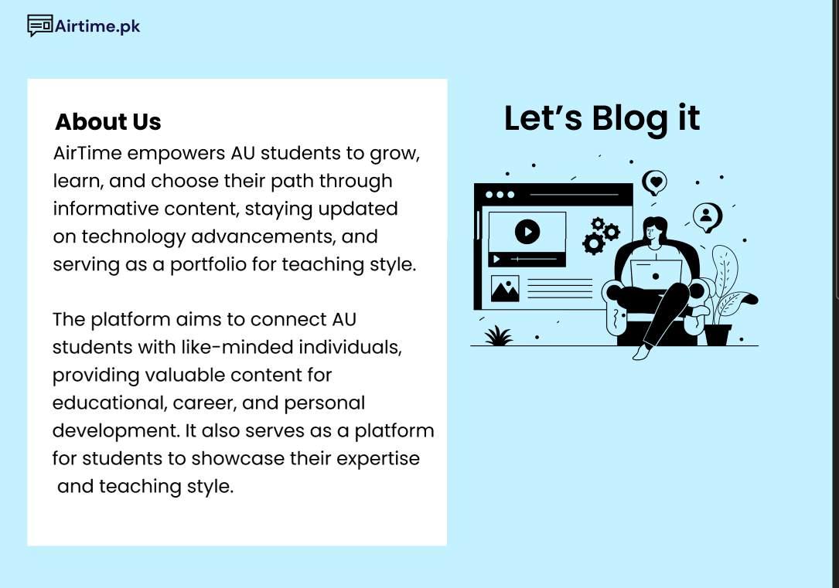

**Step 5:**

